PacMan
A Technical Report on Pacman Game

Submitted by: Hajra Sattar
2025 CYS 72

1. What Is This Project?
PacMan.java is a fully playable recreation of the classic 1980 arcade game built entirely in Java using the Swing toolkit. The whole thing lives in a single file, which is pretty impressive when you think about it. There’s no game engine, no physics library, no external framework. Just plain Java and a bit of clever design.This report walks through how it’s all put together the classes, the game loop, how collision works, how the ghosts decide where to go, and where things could be improved. Think of it as a guided tour of the codebase.

Language | Java (SE 8 and above)
UI framework | javax.swing — JPanel, JFrame, Timer, ImageIcon
Source file | PacMan.java (one file, everything inside)
Approx. size | Around 230 lines of code
How it thinks | Object-oriented and event-driven
Threading | Single-threaded on the Swing Event Dispatch Thread
Frame rate | Around 25 frames per second (Timer fires every 40 ms)
Board size | 21 rows × 19 columns of 32 px tiles — 608 × 672 pixels total

2. How the Code Is Organised

2.1 The PacMan class (the heart of everything)
The main class is called PacMan, and it does a lot. It extends JPanel (so it can draw itself), and it implements two interfaces: ActionListener (so the game timer can call it every tick) and KeyListener (so it knows when you press an arrow key). Normally you’d split these concerns across multiple classes, but for a small game like this, keeping it all together actually makes the code quite readable.

The fields you’ll see most often
- rowCount, columnCount, tileSize — the grid dimensions (21 × 19, 32 px per tile)
- walls, foods, ghosts — three HashSet<Block> collections, one for each object type
- pacman — a single Block that represents the player
- gameLoop — the javax.swing.Timer that drives the whole game
- score, lives, gameOver — the basic state of the game at any moment
- directions[] and random — used by the ghost movement logic

2.2 The Block class ( one class to rule them all)
Inside PacMan there’s an inner class called Block. It’s used for literally everything: walls, food pellets, ghosts, and PacMan himself. Each Block knows its position and size (the bounding box), which image to draw, where it started (so it can reset), and which direction it’s currently heading.

x, y, width, height | The axis-aligned bounding box — used for both drawing and collision
image | The java.awt.Image to display for this object
startX, startY | Where to send this object when it needs to reset (after a life is lost)
direction | Current heading as a char: U, D, L, or R
velocityX, velocityY | Pixels moved per tick — always ±tileSize/4, which is ±8 px
updateDirection(char) | Tries to change heading; reverses immediately if the new direction hits a wall
updateVelocity() | Converts the direction char into an actual velocity vector
reset() | Teleports the object straight back to its starting coordinates

3. The Big Picture — Architecture Diagram
Here’s a visual map of how all the pieces connect. The diagram shows the full class hierarchy, the key methods, how they interact, and where the data (tile map, assets) feeds in. Boxes you see are colour-coded by role: purple for the core class, coral for the inner class, blue for methods, pink for the game loop, and green for data.

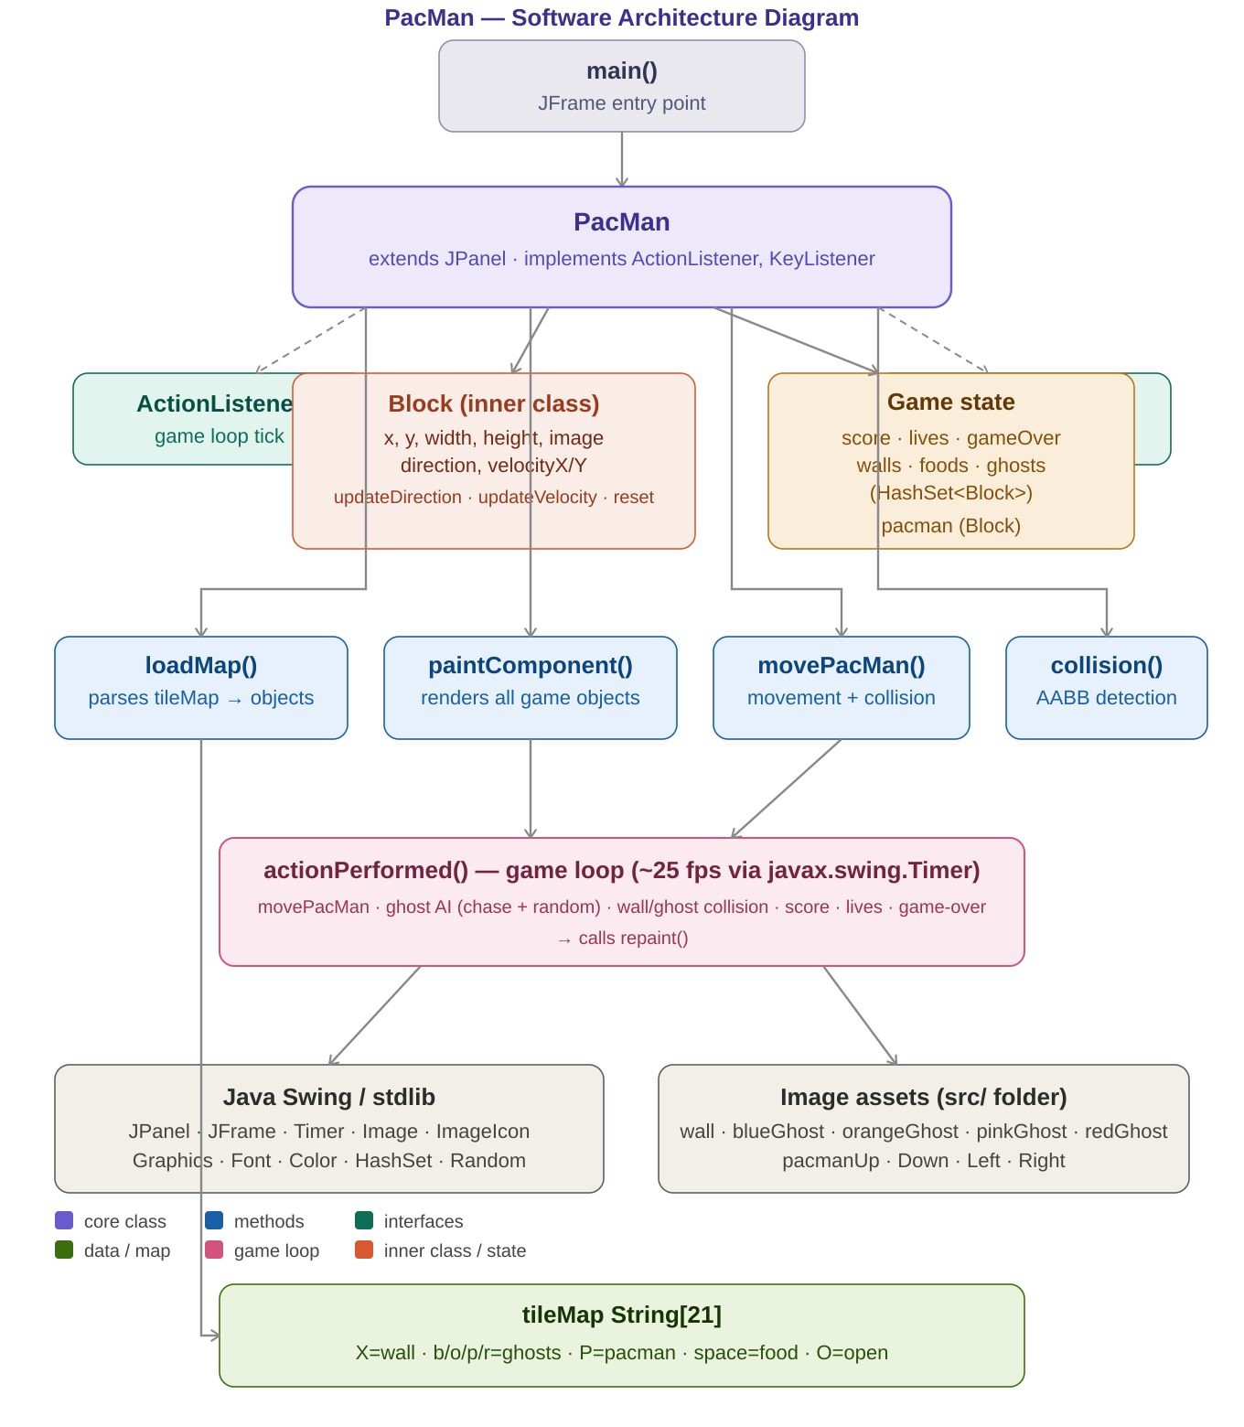
Figure 1 — PacMan Software Architecture Diagram
The four logical layers shown in the diagram can be described like this:

┌─────────────────────────────────────────────┐
│ Presentation Layer — paintComponent() + Swing │
├─────────────────────────────────────────────┤
│ Input Layer — KeyListener + keyPressed() │
├─────────────────────────────────────────────┤
│ Game Logic Layer — actionPerformed() loop │
│ movePacMan · ghost AI · collision · scoring │
├─────────────────────────────────────────────┤
│ Data Layer — tileMap[] · loadMap() · Block sets │
└─────────────────────────────────────────────┘
Java Swing / AWT (below everything)

4. Method Reference
Here’s a breakdown of every meaningful method in the file — what it takes in, what it returns, and in plain language, what it’s actually responsible for.

Method | Signature | What it actually does
PacMan() | constructor → void | Sets up the board, loads all the images, calls loadMap() to build the level, and kicks off the Timer
loadMap() | → void | Reads through the tileMap string array character by character and creates Block objects for walls, food, ghosts, and PacMan
paintComponent(g) | Graphics → void | Draws everything on screen in the right order: PacMan first, then ghosts, walls, food dots, and the score/lives HUD
movePacMan() | → void | Moves PacMan by its current velocity, bounces back if it hits a wall, and removes any food pellet it overlaps (score + 10)
collision(a, b) | Block, Block → boolean | Simple AABB rectangle overlap test — returns true if two Blocks are touching or overlapping
actionPerformed(e) | ActionEvent → void | Called by the Timer every 40 ms: runs movePacMan, moves ghosts, checks for hits, updates score/lives, and calls repaint()
keyPressed(e) | KeyEvent → void | Reads arrow key input, updates PacMan’s direction, and swaps the sprite image to match the new heading
main(args) | String[] → void | Creates the JFrame window, drops the PacMan panel inside, centres it on screen, and makes it visible

5. The Game Loop
The game loop is the engine that keeps everything alive. A javax.swing.Timer fires every 40 milliseconds, which gives us roughly 25 frames per second. Each time it fires, actionPerformed() runs through this sequence:

1. If the game is already over, stop immediately.
2. Call movePacMan():
└─ Shift PacMan by its current velocity
└─ If it overlaps a wall, undo the move
└─ If it overlaps a food dot, eat it (score += 10)
3. For every ghost on the board:
a. 10% of the time: aim toward PacMan along the longer axis
b. Move the ghost by its current velocity
c. If it hits a wall: undo move, pick a random new direction
d. If it touches PacMan:
└─ Lose a life, reset everyone to their start positions
└─ If lives hit zero: game over, stop the Timer, show dialog
4. Call repaint() to trigger a fresh frame
How the ghost AI works
Ghosts aren’t dumb, but they’re not exactly geniuses either. On any given tick there’s a 10% chance a ghost will look at PacMan’s position, figure out whether the horizontal or vertical gap is bigger, and move toward him along that axis. The other 90% of the time they just keep going in whatever direction they’re already heading — and if they hit a wall, they pick a random new direction. It creates a surprisingly believable chase without any real pathfinding.

6. Collision Detection
Every interaction in this game PacMan eating food, a ghost catching PacMan, any object bouncing off a wall uses the same single collision() method. It’s an AABB test (Axis-Aligned Bounding Box), which is just a fancy way of saying: check if two rectangles overlap.

boolean collision(Block a, Block b) {
return a.x < b.x + b.width &&
a.x + a.width > b.x &&
a.y < b.y + b.height &&
a.y + a.height > b.y;
}

It’s four lines, it’s fast, and it works for every object type in the game. The beauty of using a generic Block class for everything is that the same collision function works whether you’re checking PacMan against a wall or a ghost against another ghost.

7. The Tile Map( How the Level Is Built)
The game board isn’t loaded from a file — it’s hard-coded as a String array called tileMap, with 21 rows and 19 characters per row. Each character tells loadMap() what object to place at that grid position:

X | A wall tile — adds a Block to the walls set
O | Empty / void space — nothing is placed here
(space) | An open corridor — a small 4×4 px food dot is placed here
P | Where PacMan starts
b | Where the blue ghost spawns
o | Where the orange ghost spawns
p | Where the pink ghost spawns
r | Where the red ghost spawns

Food dots are nudged 14 px inward (x+14, y+14) so they appear centred inside their tile rather than sitting at the top-left corner. The four ghosts all spawn near the middle of the map, close together.

8. How the Screen Gets Drawn
Every frame, Swing calls paintComponent() and hands it a Graphics object to draw with. The order things are drawn in matters later items appear on top of earlier ones. Here’s the z-order:
paintComponent(Graphics g)
├── 1. super.paintComponent(g) ← wipes the canvas (background = black)
├── 2. PacMan sprite ← drawn first so ghosts appear over him
├── 3. Ghost sprites ← looped from the ghosts HashSet
├── 4. Wall tiles ← looped from the walls HashSet
├── 5. Food dots ← white 4×4 px rectangles
└── 6. HUD text ← "Lives: X Score: Y" in white
You might notice walls are drawn after ghosts and PacMan. In practice it doesn’t matter because entities never overlap with walls during normal gameplay the collision system prevents that. But if you’re ever debugging something weird visually, it’s useful to know the order

9. Image Assets
All the sprites are loaded when the game starts, using ImageIcon to read PNG files from the src/ folder. There’s no lazy loading or caching everything gets pulled in upfront in the constructor.

wall.png | The 32×32 px wall tile, tiled across every X in the map
blueGhost.png | Sprite for the blue ghost (spawned at ‘b’)
orangeGhost.png | Sprite for the orange ghost (spawned at ‘o’)
pinkGhost.png | Sprite for the pink ghost (spawned at ‘p’)
redGhost.png | Sprite for the red ghost (spawned at ‘r’)
pacmanUp.png | Shown when PacMan is moving upward
pacmanDown.png | Shown when PacMan is moving downward
pacmanLeft.png | Shown when PacMan is moving left
pacmanRight.png | The default — shown on startup and when moving right

11. Final Thoughts
All things considered, PacMan.java is a genuinely impressive single-file project. It captures the core feel of the original game the frantic movement, the ghost chase, the satisfying dot-eating using nothing but standard Java libraries. Reading through it is a great way to understand how event-driven game loops work in practice.
If this were to grow into something bigger, the natural next steps would be: splitting model, view, and controller into separate classes; adding an asset manager so images aren’t hard-coded to a path; giving each ghost its own movement personality; and implementing at least basic BFS pathfinding so ghosts don’t get stuck. But as a learning project and a working game? It does the job really well.

